The Windows 2000 TCP/IP network model

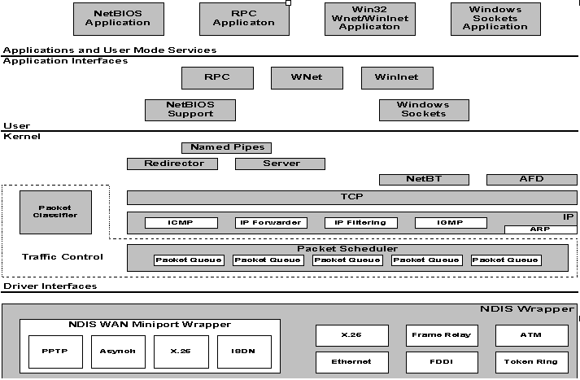

The Microsoft TCP/IP suite contains core protocol elements, services, and the interfaces between them. The Transport Driver Interface (TDI) and the Network Device Interface Specification (NDIS) are public, and their specifications are available from Microsoft. In addition, there are a number of higher-level interfaces available to user-mode applications. The most commonly-used are Windows Sockets, remote procedure call (RPC), and NetBIOS.

http://www.microsoft.com/technet/itsolutions/network/deploy/depovg/tcpip2k.mspx

